Digital Transformation Webinar - 2018 Series
Exploring Insurtech – a thought leader’s perspective
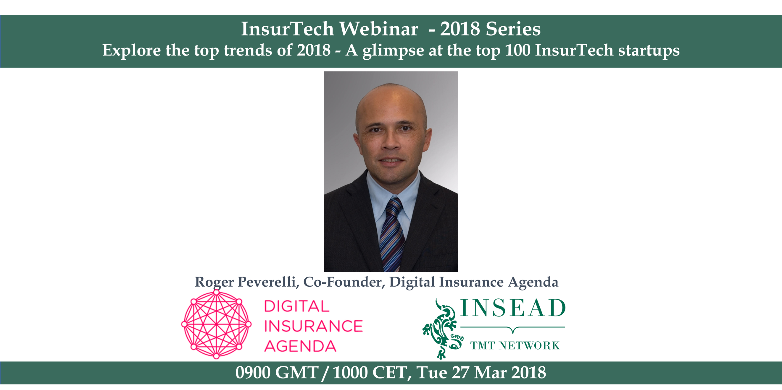

The role of money is changing, and its guardians have to as well. Blockchain is knocking at the gates of staid Insurance companies and Financial Institutions. How they’ll react will have an impact on the cost of business going forward.
By 2020, incumbent Insurance & Financial industries will likely look very different than their current avatar.
The winning insurance firms of the future will be those that leverage the most innovative Insurtech solutions to accelerate their digital strategy.

To provide a picture of what’s happening in Insurtech, we’ve invited Roger Peverelli of the Digital Insurance Agenda. He will join us on March 27th at 10 AM CET.

Please REGISTER for this webinar with your insead.edu email address

As previously, the idea is to engage alumni in this journey. We're crowdsourcing the questions from you, so, as you register, please send us the 1 question you want to ask Roger.

Host: Minh Tran

What to expect:
Roger is the author of international bestsellers 'Reinventing Financial Services' and 'Reinventing Customer Engagement'. He is a well-known speaker and hosts Financial Industry luminaries at conferences across the globe
Roger will talk to us about the top trends in Insurtech and also provide us with a glimpse of some of the top Insurtech disrupters he came across in the recent past.

If you are buying insurance for personal or professional reasons, this Webinar provides a quick lay of the land & what’s on the horizon.

Join us for this first Webinar of a series to explore trends in Insurtech, Fintech, Blockchain & Corporate Venture Capital(CVC).

If you want to participate / contribute in any way, please feel free to reach out to tmtnetwork@insead.edu

