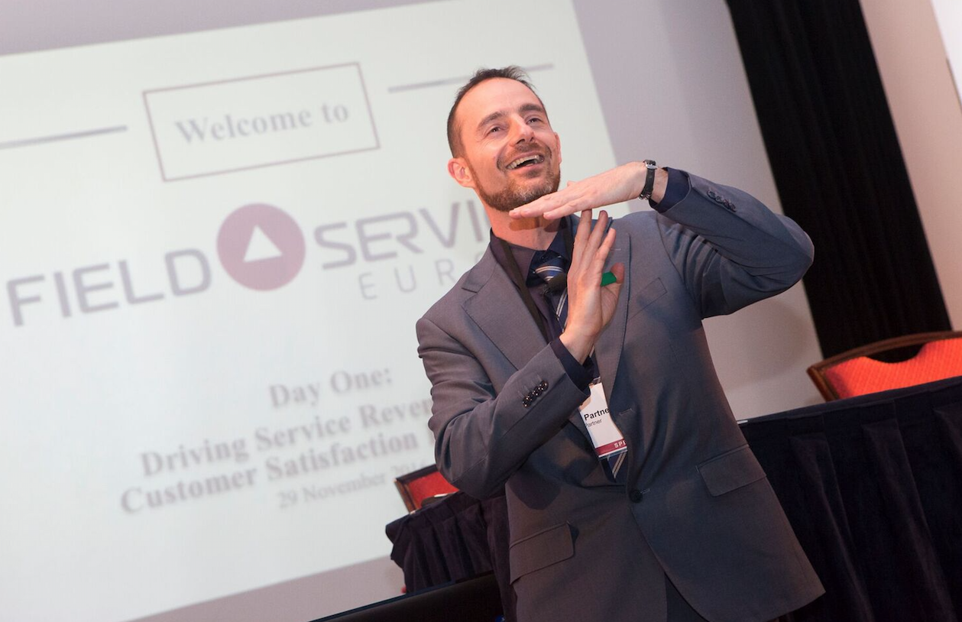

Fabrizio Battaglia

Fabrizio is an engaging facilitator with a strong passion for linking learning and measurable performance.
He facilitates workshops, coaches and speaks with passion in various international conferences. He is an executive partner of Global Partners, a global training company with impactful personal development methodologies for technical service and sales people: "You learn how to drive a car and never forget. Why can’t business training have the same impact? "
Native French and Italian speaker, with working experience in more than 20 countries he is naturally at ease in multicultural environments. His scientific background (Ecole Centrale) and his INSEAD -Tsinghua Executive MBA allow him to easily grasp the broad challenges of today’s fast evolving Industry.
Fabrizio also holds several certifications in the area of coaching and management development.
Earlier in his life, Fabrizio has collaborated with STMicroelectronics for 12 years. First in the US, as a product engineer, before moving to France for the Corporate University where he developed many programs including an international Master of Science in Microelectronics with renowned French Schools (Ecoles des Mines / Centrale). He also spent 7 years in Singapore where he headed the Institute of Sales and Marketing for ST, before coming back to Europe.
Happily married, father of two, he shares his time between south west of France and north of Italy where he loves spending time with his family in the beautiful region of Brianza.

